2nd National Competition with International Participation
"PRESERVING THE NATURE OF PLANET EARTH"
Dedicated to International Earth Day
22.04.2025 year
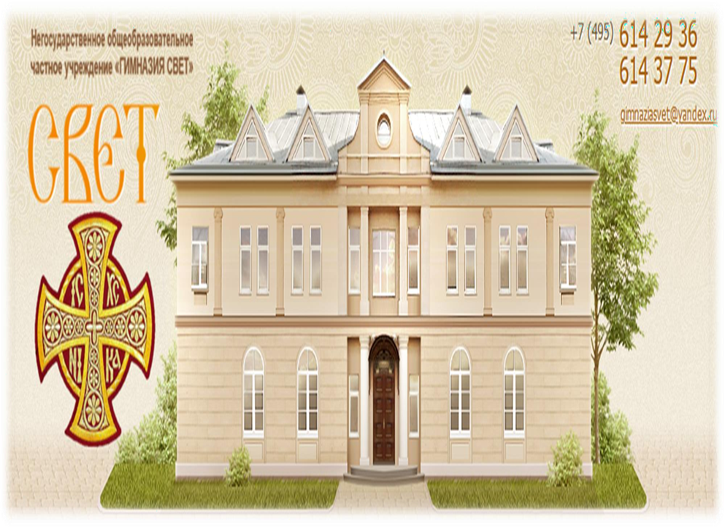

Manager: София Андреевна, тел.: 8-903-748-17-23, schatz91@bk.ru
Неправителствено образователно частно учреждение „Гимназия Свет“, Москва

Drawings and projects in SCRATCH
- „Сортиране на отпадъци“ от Иван Козуб, втори клас
"Waste Sorting" by Ivan Kozub, second grade“
https://scratch.mit.edu/projects/1144386957
- „Събирач на боклук“, направен от Алексей Шахов, втори клас
"Garbage collector" made by Alexey Shakhov, second grade“
https://scratch.mit.edu/projects/1144361953
Alexey Shakov
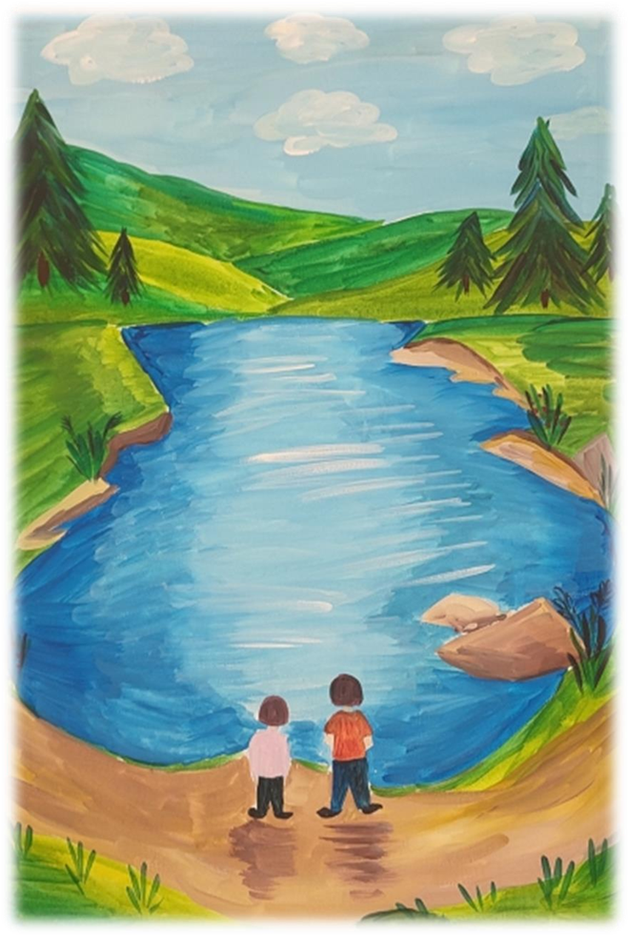
/ Competition Themes:
“A clean environment means a better life on Earth.”/
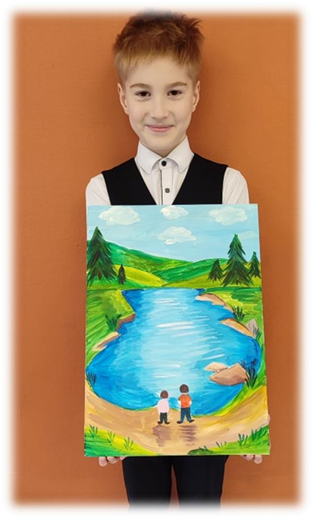
/ Alexey Shakov/
Ivan Kozub
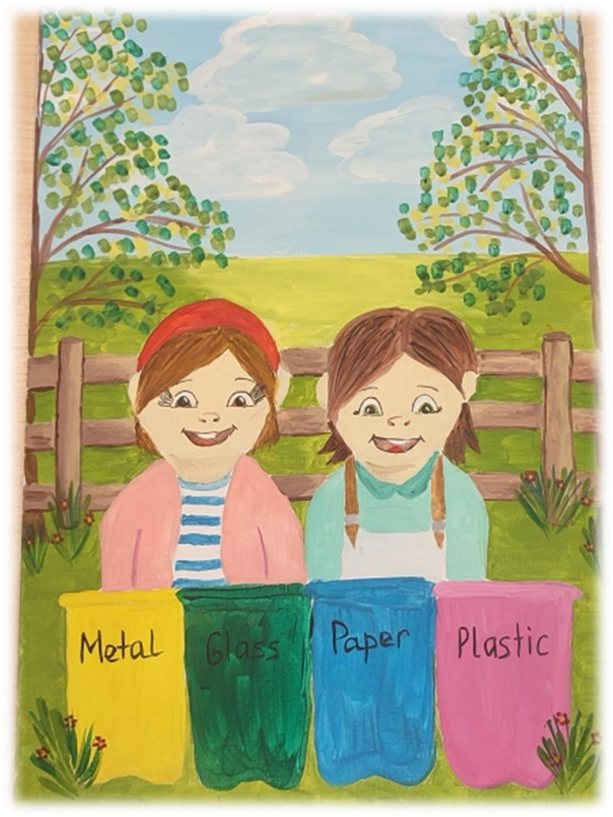
/“Turn waste into resources: separate and recycle trash.”/
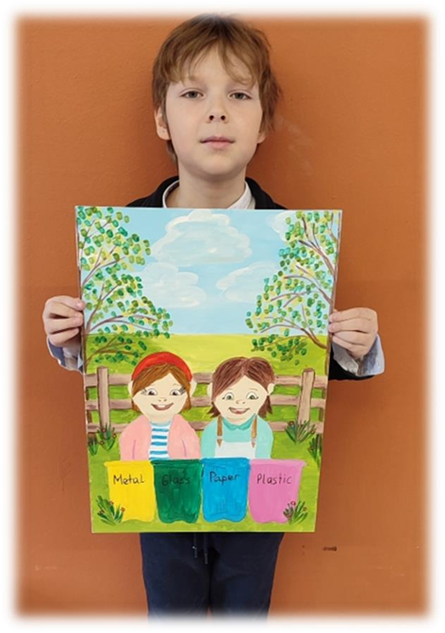
/ Ivan Kozub/
Evdokia Krasnoshchekova
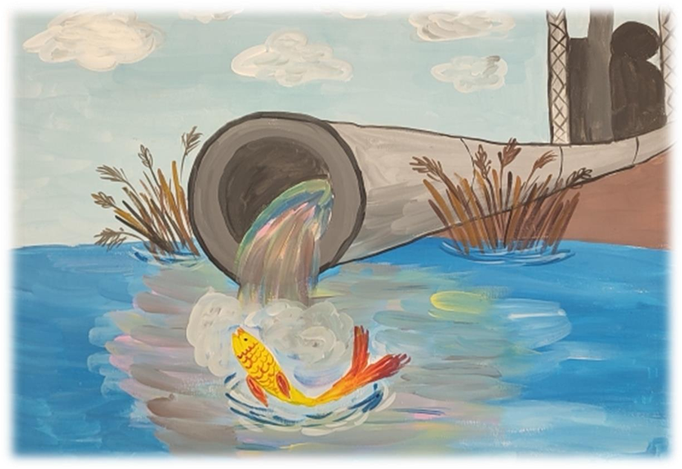
/ „Take care of the water bodies in your local area.”/
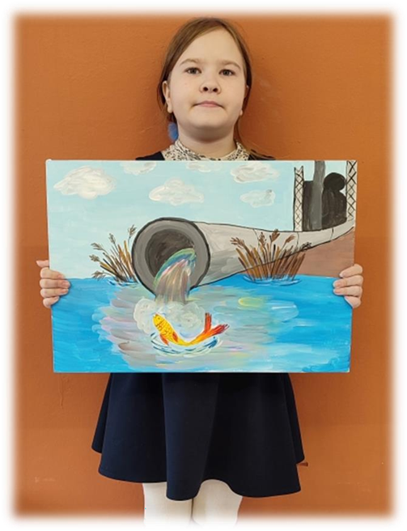
/ Evdokia Krasnoshchekova/
Vyacheslav Tkachev
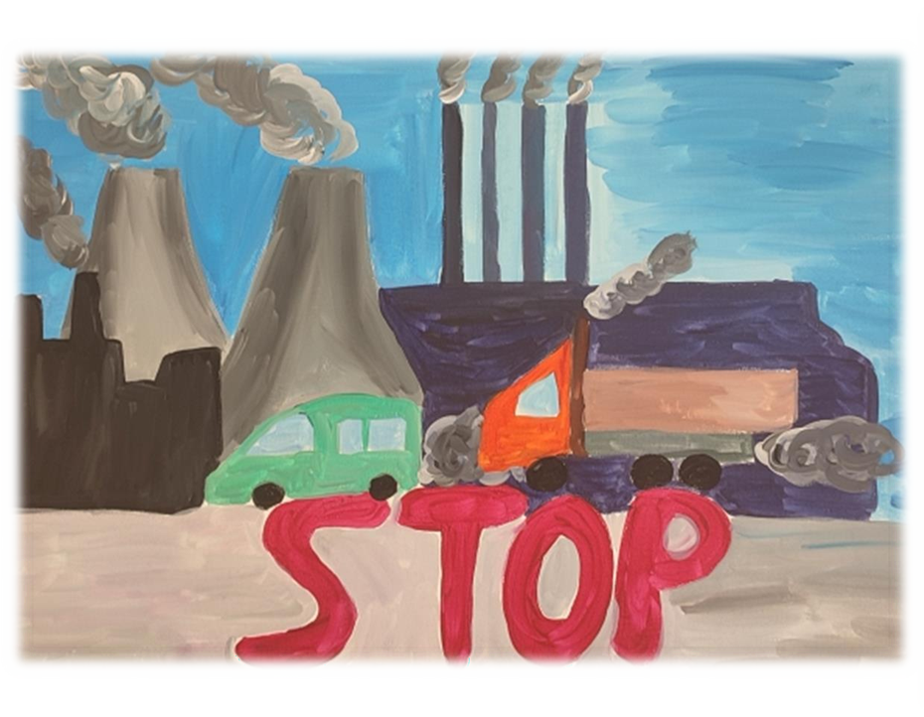
/ “Preserve the air we breathe from pollution and toxins.”/

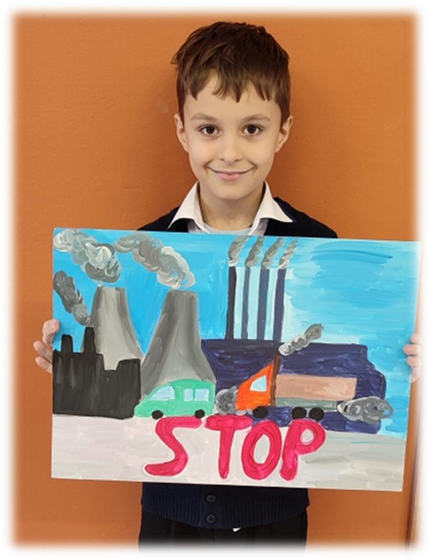
/ Vyacheslav Tkachev/
Mikhail Ralnikov
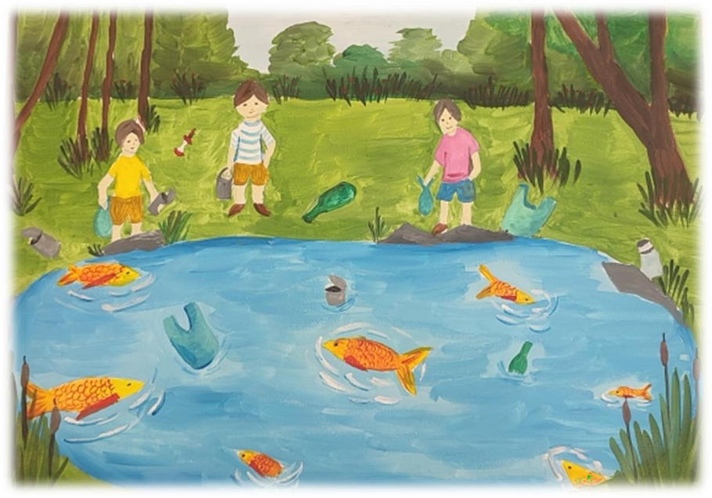
/“Protect ecological trails from human destruction and maintain their purity.”/
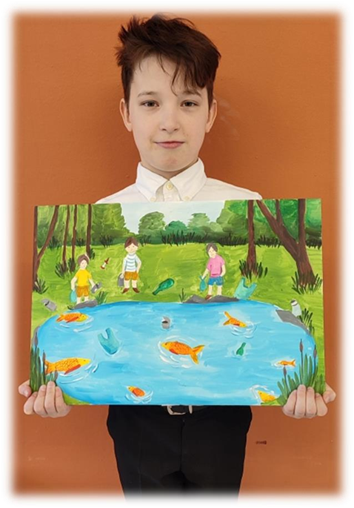
/ Mikhail Ralnikov/
Maria Velez – Bracho Losa
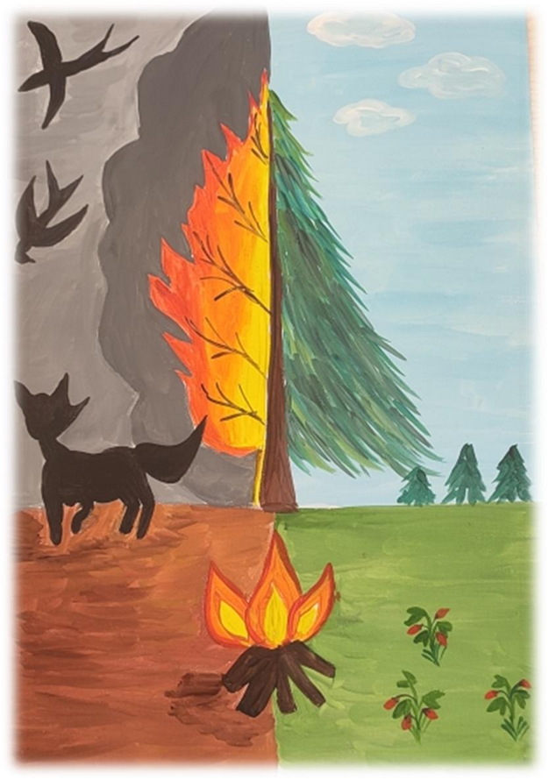
/ “Our actions matter if we want a clean environment.”/
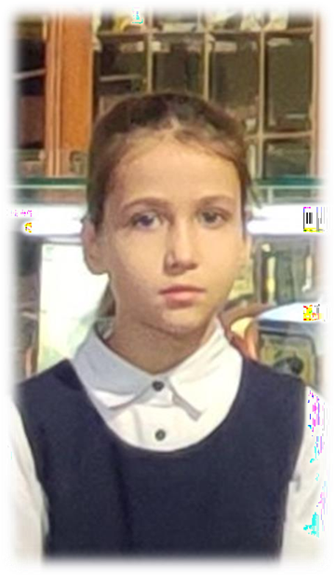
/ Maria Velez – Bracho Losa/
Mikhail Korchagin
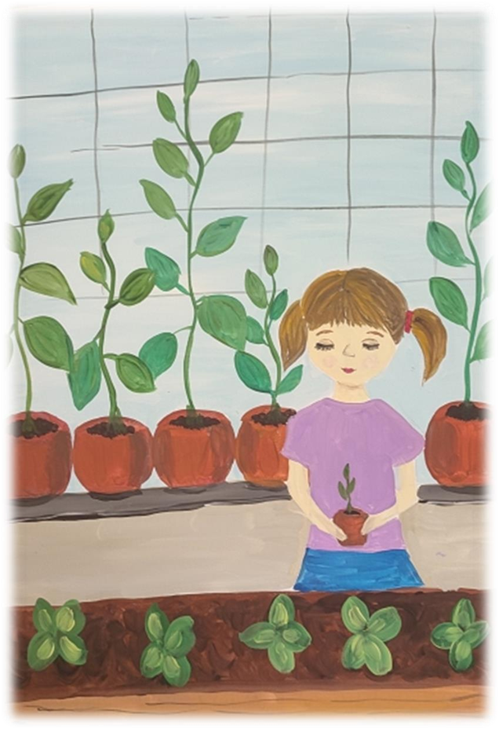
/ “My ideal for a home and garden as ecological spaces.”/
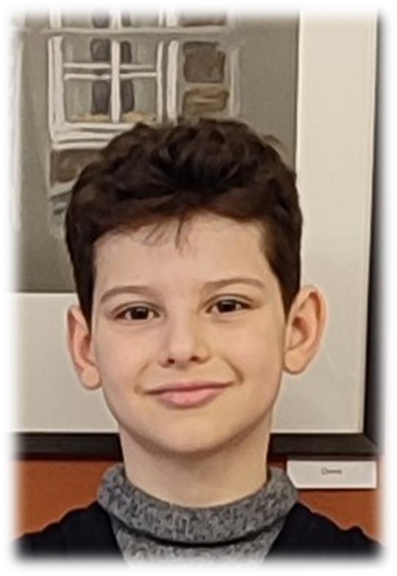
/Mikhail Korchagin/

