PRIMARY SCHOOL "ST. ST. CYRIL AND METHODIUS"
Village of Rupite, Municipality of Petrich, Blagoevgrad Region
Email: info-104017@edu.mon.bg

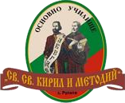

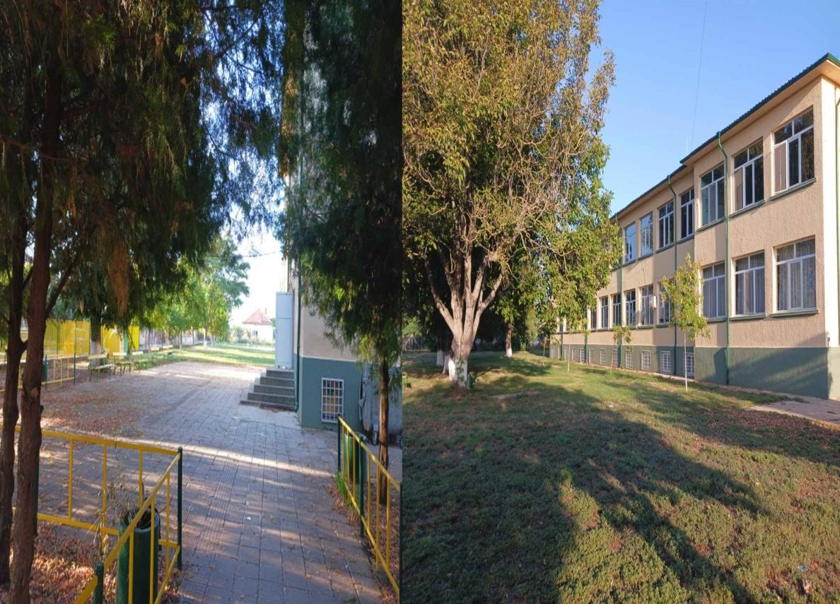
Dear Parents and Teachers, Dear Students,
The Organizing Committee of Primary School "St. St. Cyril and Methodius," Village of Rupite, invites you to participate in the
2nd National Competition with International Participation
"PRESERVING THE NATURE OF PLANET EARTH"
Dedicated to International Earth Day
Established in April 2024
Second Edition
Village of Rupite, Municipality of Petrich, Blagoevgrad Region

